**STRATEGIES FOR COEXISTING: JUVENILE PINK AND CHUM SALMON DIETS AND INTERACTIONS IN A DYNAMIC SECTION OF COASTAL MIGRATION**

by

Vanessa Rose Zahner

B.Sc., The University of British Columbia, 2015

A THESIS SUBMITTED IN PARTIAL FULFILLMENT OF

THE REQUIREMENTS FOR THE DEGREE OF

MASTER OF SCIENCE

in

THE FACULTY OF GRADUATE AND POSTDOCTORAL STUDIES

(Oceanography)

THE UNIVERSITY OF BRITISH COLUMBIA

(Vancouver)

Current draft version: July 31st, 2020

© Vanessa Rose Zahner, 2020

The following individuals certify that they have read, and recommend to the Faculty of Graduate and Postdoctoral Studies for acceptance, a thesis/dissertation entitled:

|  |
| --- |
| **STRATEGIES FOR COEXISTING: JUVENILE PINK AND CHUM SALMON DIETS AND INTERACTIONS IN A DYNAMIC SECTION OF COASTAL MIGRATION** |

|  |  |  |
| --- | --- | --- |
| submitted by | Vanessa Rose Zahner | in partial fulfillment of the requirements for |
| the degree of | Master of Science | |
| in | Oceanography | |

**Examining Committee:**

|  |
| --- |
| Brian P.V. Hunt, Institute for the Oceans and Fisheries |
| Co-supervisor |
| Evgeny A. Pakhomov, Earth and Ocean Sciences |
| Co-supervisor |
| Colin K. Levings, Institute for Resources, Environment and Sustainability |
| Supervisory Committee Member |
| TBD *****! |
| Additional Examiner |

# Abstract

TBD (word count 350 max)

# Lay Summary

TBD (word count 150 max)

# Preface

This thesis research is the independent, original and unpublished work of Vanessa Rose Zahner. Co-supervisors Dr. Evgeny Pakhomov and Dr. Brian Hunt helped shape the initial project ideas and layout of fish sample sizes. The research was done in collaboration with the Hakai Institute’s Juvenile Salmon Program to gain a better understanding of the early marine migration of salmon. Hakai field crews at Quadra Island Station and Salmon Coast Field Station collected juvenile outmigrating salmon and lab crews performed necessary dissections. The fish sampling was approved by UBC’s Animal Care Committee, Protocol A19-0025, and under the DFO license XR 63 2019. Sample processing for zooplankton taxonomy was performed by Andrea Le, Samantha James, Jihyun Kim and Jessica Schaub. All of the salmon stomach content processing, data analysis and writing was done solely by Vanessa Rose Zahner. The raw dataset of salmon stomach contents and analysis code are freely accessible at: DOI FOR HAKAI PACKAGE.

.

# Table of Contents

Abstract iii

Lay Summary iv

Preface v

Table of Contents vi

List of Tables viii

List of Figures ix

List of Illustrations xi

List of Symbols xii

List of Abbreviations xiii

Glossary xiv

Acknowledgements xv

Dedication xvi

Chapter 1: Introduction 1

Chapter 2: Juvenile pink and chum salmon divide prey resources in response to low foraging 2

2.1 Introduction 2

2.2 Methods 6

2.3 Results 10

2.4 Discussion 13

2.4.1 Diets in contrasting foraging conditions 13

2.4.2 Competition in contrasting foraging conditions 14

2.4.3 Trophic niches of juvenile pink and chum salmon 15

2.5 Conclusion 16

2.6 Tables 18

2.7 Figures 22

Chapter 3: Salmon trophic interactions shift with prey phenology and migration timing 31

3.1 Introduction 31

3.2 Methods 31

3.3 Results 31

3.4 Discussion 31

3.5 Conclusion 31

3.6 Tables 32

3.7 Figures 33

Chapter 4: Conclusion 34

References 35

Appendix 42

# List of Tables

Table 2.1: Sample size, dates, environmental surface data, and zooplankton biomass by size fraction 18

Table 2.2: Zooplankton relative abundance by main groups 19

Table 2.3: Salmon biological data including wet weight (WW), fork length (FL), gut fullness index (GFI), showing mean and standard error. As well as the number of empty stomachs and percent dietary overlap between pink and chum salmon at each site 20

Table 2.4: Diet composition summary by average relative biomass, expressed as a percent, of the main groups of prey for pink (PI) and chum (CU) salmon 21

Table 3.1 Sampling 32

Table 3.2 Zooplankton relative abundance 32

Table 3.3 Indices 32

Table 3.4 Diet composition summary (% wet weight) of juvenile salmon by site and year 32

Table A.1: Diet composition summary of juvenile salmon for each sampling date 2015-2016 42

# List of Figures

Figure 2.1: Map of salmon survey stations in the Discovery Islands and Johnstone Strait. Inset map (left) shows the British Columbia coast with the study region highlighted by the red box. 22

Figure 2.2: Temperature (left y-axis, black) and salinity (right y-axis, red) values paired with the salmon surveys, the sites are listed in the same order on the x-axis as they appear on the map. 23

Figure 2.3: Biomass of zooplankton, displaying total biomass and contribution by size fractions. Data are missing for J02 and is shown as blank. Sites are listed in the same order as on the map. 24

Figure 2.4: Average relative abundance of zooplankton groups, “Other” includes cladocerans, barnacle larvae and euphausiid eggs. Sites are listed in the same order as they appear on the map. 25

Figure 2.5: Average relative biomass of the main prey groups for juvenile pink (top) and chum salmon (bottom), the sites are listed in the same order on the x-axis as they appear on the map. ‘Other’ prey group includes cyclopoids, barnacles, bivalves, cladocerans, pteropods, and more. 26

Figure 2.6: Non-metric multidimensional scaling (NMDS) plot of juvenile pink and chum salmon diet composition (see text for data transformations). Each data point is a salmon stomach and distance between points express dissimilarity, axes have no units. Shapes show salmon species, color displays sample site and ellipses indicate standard deviation of each region (see legends). “Stress” is how well distances between points are retained when displayed in two-dimensions, stress values under 0.2 are good representations of data. For this NMDS plot, the stress = 0.17. 27

Figure 2.7: Cluster analysis of juvenile pink and chum diet composition using average linkage clustering. Dendrogram label colors represent sites (same colors scheme as previous figure). 29

Figure 2.8: Gut fullness index (food weight / fish body weight * 100) values of juvenile pink and chum salmon (left y-axis), the black bar indicates the mean, boxes show the inter-quartile range (IQR), whiskers are data within 1.5*IQR and shown as points are outliers beyond the 1.5*IQR. The dark red line (right y-axis) is the percent similarity or diet overlap index between pink and chum salmon, the sites are listed in the same order on the x-axis as they appear on the map. 29

Figure 3.1 Map 33

Figure 3.2 Temperature and salinity 33

Figure 3.3 Zooplankton biomass by size fraction 33

Figure 3.4 Zooplankton relative abundance 33

Figure 3.5 Diet composition 33

Figure 3.6 GFI 33

Figure 3.7 NMDS 33

# List of Illustrations

Illustration 1: (Placeholder) Haida pink and chum salmon by SGidGang.Xaal *Shoshannah Greene*. xvi

# List of Symbols

± Plus-minus

μm Micrometer (10-6 m)

‰ Parts per thousand

°C Degrees Celsius

# List of Abbreviations

DI Discovery Islands

BW Body weight

FO Frequency of occurrence

GFI Gut fullness index

JS Johnstone Strait

NMDS Non-metric multidimensional scaling

PSI Percent similarity index

QCSt Queen Charlotte Strait

SoG Strait of Georgia

SE Standard error

WW Wet weight

# Glossary

Littoral Nearshore

# Acknowledgements

TBD (committee, lab mates, friends/family, funding, UBC FNHL, Indigenous scientists, salmon)

# Dedication

*Naanii Sandy, Kuniisii, ‘Salaana*

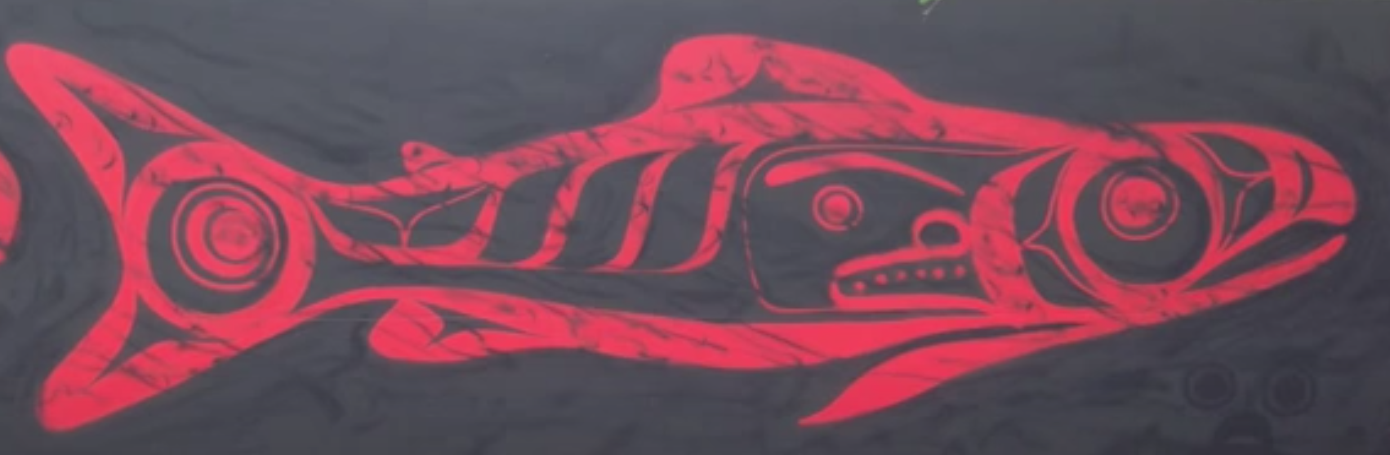

**

Illustration 1: (Placeholder) Haida pink and chum salmon by SGidGang.Xaal *Shoshannah Greene*.

## Introduction

TBD …

## Juvenile pink and chum salmon divide prey resources in response to low foraging

### Introduction

Pacific salmon (*Oncorhynchus* spp.) are irreplaceable to the cultures, food security and ecosystems within the Pacific Northwest, migrating from freshwater to the Pacific Ocean then returning to their natal habitats (Marushka et al., 2019; Quinn, 2018; Wyllie de Echeverria & Thornton, 2019). While pink (*O. gorbuscha*) and chum salmon (*O. keta*) have the highest abundance and biomass (respectively) of all salmon species due to hatchery production, there have been regional declines in British Columbia (Malick & Cox, 2016; Ruggerone & Irvine, 2018). Commercial fisheries for salmon have decreased in response to declining stocks and traditional harvest for many coastal First Nations have also been reduced (Garner & Parfitt, 2006; Michael C. Healey, 2009). Despite ongoing research on salmon, predictions of adults returning to spawn are highly variable, often lower than expected, and salmon fisheries have become increasingly difficult to manage (Beamish 2017).

Chum and pink salmon are species that leave freshwater soon after emergence, heading straight towards the estuary and the ocean at a relatively small size (Groot & Margolis, 1991). The juveniles must contend with the physiological challenges of smoltification, multiple potential predators, and a new foraging environment (Levings, 2016). Mortality for salmon smolts can be high, and research has shown that growth during the early marine phase is an important determinant of the cohort strength during the first winter at sea and the likelihood of adult survival (Beamish & Mahnken, 2001).

Prey availability and salmon foraging behaviour are important factors for growing quickly during the early marine life (Brodeur, 1990). Patchiness of zooplankton in the ocean leads to relatively generalist salmon feeding (Osgood et al., 2016). However, there are energetic trade-offs and decisions regarding effort required to capture prey, leading to the species specific trophic niches (Gill, 2003). Indeed, salmon species have unique foraging behaviour and preferences, allowing them to portion available prey resources (Beamish et al., 2003). For example, pink, chum and sockeye salmon are planktivorous during early marine life, whereas chinook and coho salmon are piscivorous (ref).

Pink and chum diets vary in response to prey availability, size, intra- and interspecific competition (refs). Small pink and chum salmon often forage in the nearshore coastal environment, consuming prey such as harpacticoids (refs), shifting to larger calanoids, decapods, appendicularians, amphipods and euphausiids as salmon size increases (refs). Pink and chum salmon therefore have the potential to either compete for food or occupy different trophic niches, which has been studied with stable isotopes but not stomach contents (Jenkins, 2011; Pocheville, 2015).

Niche can be defined as a combination of the conditions allowing a species to satisfy the minimum requirements of survival and the impact of the species on environmental conditions (Chase & Leibold, 2003). Therefore, “trophic niche” of salmon species can be considered the prey resources consumed to meet energetic demands and the effect of salmon foraging on the zooplankton community and other species (Jenkins, 2011). Essentially, trophic niche is an organism’s role within the food web; it can be dynamic over time and coexisting species cannot occupy the same niche as this leads to competitive exclusion (Hardin, 1960).

Pink salmon are an example of dominant competitors for food resources. They actively feed on crustacean zooplankton and in high abundance years can cause trophic cascades (Batten et al., 2018; Ruggerone & Nielsen, 2004). Emerging studies on competition have shown pink salmon to negatively affect the growth and survival of other salmonids, herring, sea birds and killer whales (Beamish et al., 2010; Pearson et al., 2012; Ruggerone et al., 2019; Springer et al., 2018). Chum salmon, on the other hand, have more flexible feeding strategies, with the tendency to prey shift towards gelatinous zooplankton in response to competition or limited food resources (Johnson & Schindler, 2009; Tadokoro et al., 1996). Chum salmon have a substantially larger stomach than other salmon which enables them to specialize on large gelatinous prey to meet their energetic requirements (Welch, 1997). While these trends for pink and chum salmon have been shown in adults, research is limited for these foraging behaviours in outmigrating juveniles.

The zooplankton communities migrating salmon encounter are largely produced by bottom up effects such as mixing, nutrients, temperature, salinity, and phytoplankton productivity (Mackas et al., 2001). In southern British Columbia, the majority of pink and chum salmon originate from the Fraser River and the juveniles migrate northward through the Strait of Georgia, a seasonally stratified and productive region (DFO, 2020). North of the Strait of Georgia (SoG) are the complex and tidally mixed areas of the Discovery Islands (DI) and Johnstone Strait (JS), which differ in oceanographic properties and zooplankton communities (Khangaonkar et al., 2017; Mahara, 2018). Recent studies have hypothesized these regions to be a “trophic gauntlet” for juvenile salmon, and sockeye salmon have indeed been demonstrated to be food limited in these tidally mixed waters, with gut fullness <0.5% of their body weight (James et al., 2020; Mckinnell et al., 2014). Salmon then migrate through Queen Charlotte Strait (QCSt), where they may be able to forage successfully and replenish from experienced food shortages (Mcqueen & Ware, 2006). Therefore, salmon are able to survive this challenging route of DI-JS since it is book-ended with high feeding in the SoG and QCSt, but if ocean conditions change and these refuge areas become unproductive, it can have devastating effects on salmon survival (Mckinnell et al., 2014). Since pink and chum salmon have similar foraging and migration patterns to sockeye, they are also exposed to the trophic gauntlet potentially impacting competition for resources and affecting juvenile growth and survival (Healey, 1991).

The conditions salmon encounter in this region of B.C. are representative of environments encountered by early marine phase juvenile salmon in other regions of the Northeast Pacific (Brodeur et al., 2007). For example, Southeast Alaska has a similar coastal oceanography, with inlets, channels, archipelagos, and high amounts of tidal mixing that can influence salmon diets (Weingartner et al., 2009). In Icy Strait, Southeast Alaska, juvenile pink and chum salmon diets included calanoid copepods, euphausiids, appendicularians and amphipods. Therefore, not only does the DI-JS region represent an important section of the salmon migration route, but it is a microcosm of coastal conditions experienced by juvenile pink and chum salmon along the Northeast Pacific coast.

This research addressed a knowledge gap of pink and chum foraging behaviour and competition with varying in situ feeding conditions in tidally mixed waters during early marine migration. This study aimed to (a) quantify and compare juvenile pink and chum salmon diets in areas of contrasting foraging conditions in southern B.C.; (b) assess potential competition between juvenile pink and chum salmon and (c) describe the trophic niches juvenile pink and chum salmon occupy under contrasting foraging conditions. The prediction was that low forage availability would lead to juvenile pink and chum salmon competition and separation by niche.

### Methods

The Hakai Institute’s Juvenile Salmon Program was established in 2015 as a collaboration between the Hakai Institute, the University of British Columbia, Simon Fraser University, the University of Toronto and Salmon Coast Field Station. This ongoing program annually samples juvenile salmon as they migrate through the Discovery Islands and Johnstone Strait during the main outmigration period (May to July). The objective of the program was to improve understanding of the early marine phase of Pacific salmon, particularly factors contributing to health and survival (Hunt et al., 2018). This study focussed on 2016, which had the largest spatial sampling coverage in an effort to resolve the primary migration pathways through the region. The previous year, 2015, had similar spatial sampling coverage but there was expected and observed lower pink abundance, due to their biennial life patterns.

In the Discovery Islands, 12 sites were sampled in 2016, and in Johnstone Strait, 10 sites were sampled, to provide coverage of all possible salmon migration routes through these regions (Hunt et al., 2018). Sample coverage extended from the northern Strait of Georgia, multiple routes in the Discovery Islands, through Johnstone Strait to the beginning of Queen Charlotte Strait. For this study, six sites (three from each region) were selected, in order to obtain a sample size of 10 pink and 10 chum per set (n=120 total) while still acquiring sufficient coverage for each region, focusing on the central pathway of Discovery Islands through Oikosollo Channel. Samples for this analysis were selected from mid-June (Table 1) to align with the peak out-migration of salmon (Johnson et al., 2019).

Fish were captured using a purse seine with bunt dimensions of 27 m × 9 m with 13 mm mesh and tow area dimensions of 46 m × 9 m with 76 mm mesh. Once arrived at a site, weather and sea state were recorded, followed by a visual survey of salmon surface activity. The purse seine net was then set on a targeted school of fish. Up to 30 sockeye, 10 pink and 10 chum salmon were retained, and the remaining salmon were counted and released (Hunt et al., 2018). All retained fish were individually euthanized with tricaine methane sulfonate (MS-222) upon removal from the seine net, lengths and weights recorded, and preserved at -196 oC with liquid nitrogen in a dry shipper until the salmon samples were stored in the -80 oC freezer at the lab.

A YSI (model #15B102233 and 15C100324) was used to measure temperature and salinity at the surface and 1-meter depth, recorded while salmon were held for processing in the net. Once the purse seine set had been complete, zooplankton were sampled with a 50 cm diameter ring net with 250 μm mesh net, towed horizontally at the surface. A General Oceanic flowmeter was attached to the zooplankton net to calculate volume filtered for each sample tow. The zooplankton collected were then preserved in 4% formaldehyde for subsequent analysis.

In the lab, zooplankton samples were poured over sieves and separated into 250 μm, 1000 μm and 2000 μm size fractions before being weighed and analyzed. Wet weights were measured to the nearest 0.1 mg on an analytical balance, with non-gelatinous and gelatinous groups weighed separately. Each size fraction of zooplankton was identified to life stage and the finest taxonomic resolution possible. Each zooplankton group was then enumerated and measured with an ocular micrometer, and subsampled if necessary using a Motodo plankton splitter.

Juvenile salmon were weighed, the length recorded, then dissected and relevant samples removed, the stomachs preserved in 95% ethanol. Prior to analysis, salmon stomachs were removed from ethanol and soaked unopened for 30 minutes in tap water to reduce the brittleness of the sample. The stomach was then dissected open and the food contents removed. The entire food bolus was weighed on an analytical balance and wet weight recorded to the nearest 0.1 mg. The bolus was then placed on a petri dish with water added, and prey rearranged by species, size, life stage and digestive state. Digestive states were defined as 1) fresh prey, intact, 2) semi-fresh prey, with lost appendages or color, 3) semi-digested prey, identified to group, and 4) fully digested, and unidentified prey. If prey could not be identified to species, it was identified to the most detailed taxonomic group possible, e.g. Ctenophora and Cnidaria jellyfish, collectively grouped as “gelatinous” hereafter. For each prey group, minimum and maximum lengths were measured with an ocular micrometer, individuals were counted, and the group wet weight recorded to nearest 0.1 mg. If a stomach sample had over 1,000 prey of similar size then a ¼ subsample was processed. First, any rare or large prey were removed, data recorded, and then ¼ of remaining prey was processed.

The spatial variation in prey composition was analyzed using a multivariate approach. Prior to the analysis, rare taxonomic prey categories (occurring in less than three stomachs) were combined into higher level groupings, ignoring “digested food.” Fish stomach content wet weight was multiplied by 1.54 to correct weights for water loss after storage in ethanol (James, 2019). Relative prey biomass for each stomach was calculated and arcsine square root transformed before calculating Bray-Curtis dissimilarity. The dissimilarity matrix was used for non-metric multidimensional scaling (NMDS) ordination and agglomerative hierarchical clustering (AHC).

In addition to the multivariate statistics, various indices were calculated from the raw data. Frequency of occurrence (FO) of prey for each site and each species, was calculated as:

FO = # of stomachs with preyi / total # of stomachs

Gut fullness indices (GFI) were calculated for each fish, expressed as percent body weight:

GFI = (food bolus weight / fish weight) * 100

The Schoener percent similarity index (PSI) for species diet overlap was calculated for each site:

PSI = [Σ (minimum preyip, preyic)] * 100

Where preyip is the proportion by weight of prey *i* in pink salmon stomachs and preyic is the proportion by weight of prey *i* in chum salmon stomachs (Chipps & Garvey, 2006; Krebs, 2013).

The empty stomachs (those with no identifiable prey) in this study were excluded from the multivariate dissimilarity calculations but were included in the calculation of the above indices. The prey taxonomic detail was retained in analyses, but for summary tables and figures, “other” is prey grouped together that doesn’t contribute substantially to diets, such as amphipods, barnacle larvae, bivalve larvae, cladocerans, fish larvae/eggs, pteropods, polychaetes, etc.

### Results

The environment of Discovery Islands was characterized as warmer and fresher and Johnstone Strait was colder and more saline, and different zooplankton occured in each region (Table 1). The site nearest the northern Strait of Georgia, D07, had high freshwater influence and stratified conditions, with surface salinity of 25‰ and temperature of 17oC (Figure 1; Figure 2). Whereas, the other Discovery Islands sites were more well-mixed, D09 had 28.5‰ salinity and 12oC and D11 29‰ and 10.9 oC. and J06 are further transition points before the water properties became more well-mixed at J08 and J02, with 32‰ salinity and 10oC (Figure 1; Figure 2). The zooplankton biomass throughout this area was mostly composed of small zooplankton, in the 250 μm size fraction or gelatinous zooplankton from the 2000 μm size fraction (Figure 3), mainly calanoid and cyclopoid copepods and the ‘other’ prey types (Figure 4; Table 2).

Pink and chum collected for analysis is shown in Table 1. Size …

Juvenile chum salmon diets shifted from predominantly *Oikopleura* in Discovery Islands (44.2 – 91.0% by mass) to gelatinous in Johnstone Strait (76.1 – 96.2%) and euphausiids at the northern most site J02 (53.5%), whereas pink salmon preyed predominantly on calanoid copepods(19.8 – 85.5%) throughout all regions (Table 4; Figure 5). In addition to active selection for large (>2 mm) calanoid copepods, pink salmon also fed upon decapod larvae, and nearshore invertebrates such as insects and harpacticoid copepods. Discovery Islands can be characterized as *Oikopleura* dominant for chum salmon, with pink salmon also consuming *Oikopleura* but in much lower amounts (15.3 – 19.9%), mostly eating crustaceans. At the first Johnstone Strait site (J06) chum salmon shifted to gelatinous prey (possibly Cnidaria jellyfish) and pink salmon consumed nearshore prey, such as harpacticoids (19.3%) and insects or arachnids (16.7%). At Johnstone Strait site J08, chum salmon still consumed gelatinous prey but also had higher amounts of large calanoid copepods (15.7%), while pink salmon predominantly ate calanoids. There was a complete diet shift at the furthest seaward Johnstone Strait site (J02), where both of the salmon species consumed, albeit in different proportions, calanoids (pink 61.9%, chum 18.7%), chaetognaths (pink 5.5%, chum 21.3%) and euphausiids (pink 29.6%, chum 53.5%).

Gut fullness was consistently low throughout this area of the salmon migration route, with the exception of full and distended stomachs at the last site, Queen Charlotte Strait (Figure 8). Gut fullness indices (GFI) were generally below 0.5% body weight throughout the Discovery Islands and J06, the first Johnstone Strait site. At the mid-Johnstone Strait site J08, the GFI increased to around 1% body weight (pink 1.13% ± 0.06, chum 1.28% ± 0.04), which is still relatively low, compared to the around 7% body weight feeding intensity at site J02 (pink 7.46% ± 0.19, chum 6.20% ± 0.11). Microplastics and other non-digestible objects (glass, a rock) were found in 10% of all juvenile pink salmon stomachs in the 3 Discovery Islands sites and J06, the sites with the lowest GFI, but no chum salmon were found to have eaten non-food objects.

Empty stomachs were found throughout the Discovery Islands and the first Johnstone Strait site (Table 3). Empty stomachs were recorded for pink salmon at D07 (20%) and J06 (40%), and for chum salmon at D09 (30%) and D11 (30%). No sites had empty stomachs of both species. Ten percent of all salmon stomachs analysed were empty, in both pink and chum salmon. By region, 7% of pink salmon stomachs were empty and 20% of chum salmon in the Discovery Islands, while in Johnstone Strait no empty stomachs were recorded for chum salmon compared to 13% of pink salmon.

Dietary overlap between pink and chum salmon was relatively low and consistent in the Discovery Islands and shifted from low to high levels in Johnstone Strait (Figure 8). At the first site of the migration route, D07, dietary overlap reached 24.9%. This increased to 33.0% at D09 and then decreased to 21.7% at D11. The lowest dietary overlap, 4.8%, was observed at J06 (Figure 8). Dietary overlap at mid-Johnstone Strait J08 was 14.1% and the final site near the entrance to Queen Charlotte Strait J02 had the highest diet overlap of 59.8%. In summary, the Schoener overlap index showed consistently low to modest diet overlap between juvenile pink and chum salmon at all sites with the exception of J02.

Overall diet composition of salmon species also had no observable trends within the Discovery Islands, whereas Johnstone Strait has a clear gradient of overlap and divergence. The NMDS plot reflects the variability in Discovery Islands, and Johnstone Strait locations show the highest differentiation between species at J06, the eastern most site, then J08 next shows semi-different pink and chum salmon diets and finally, J02 has complete diet overlap (Figure 6).

A cluster analysis also displayed this same trend as the NMDS, with the two regions separated into main clusters and Johnstone Strait was subdivided by both site and species (Figure 7).  The only site to distinctly cluster together was J02, near Queen Charlotte Strait, which was similar to the pink salmon diets from J08, mid-Johnstone Strait. The pink salmon diets were somewhat comparable to the chum salmon diets at J08, but the J06 chum salmon from East Johnstone Strait had a completely separate cluster and J06 pink salmon were outliers.

### Discussion

#### Diets in contrasting foraging conditions

This study examined juvenile pink and chum salmon stomachs to characterize diets during the 2016 peak outmigration through the Discovery Islands and Johnstone Strait routes. This area that was shown to be a trophic gauntlet for juvenile sockeye salmon, is also food limiting for pink and chum salmon, and diet overlap between species was low in response (refs). However, the northern most site of J02 was shown to be a foraging hot spot for juvenile sockeye salmon in June 2015 and this trend continued in 2016 for both pink and chum salmon. Juvenile pink and chum salmon switched trophic niches throughout the region according to prey availability and species interactions, chum occupying a gelatinous niche and pink, littoral.

Juvenile salmon appear to experience a trophic gauntlet during their migration, with areas of ‘winners and losers’, where prey availability dictates which feeding strategy prevails.

The first two sites of Discovery Islands seem to have patchy feeding conditions, with empty stomachs or decapod larvae prey at D07 and around 0.5% body weight stomach fullness at D09. The next two sites in the migration is the mid-way point, the transition between the regions, and D11 had more empty chum salmon stomachs and lower amounts of *Oikopleura* prey, whereas pink salmon still fed on nearshore prey and had no empty stomachs at this location. The next site of J06, found the opposite, with no empty chum salmon stomachs feeding on gelatinous prey and empty pink salmon stomachs and unusual prey when food was present. Thus, salmon species feeding strategies will either be beneficial or detrimental depending on prey availability, and how these relationships could shift over time requires further research.

In other areas with similar coastal conditions, pink salmon have been found to utilize nearshore foraging on small crustaceans and chum salmon often prey switch to gelatinous (Godin, 1981; Tadokoro et al., 1996). Previous studies have found harpacticoid copepods as a prey for both species, and calanoid copepods were another important component in pink and chum salmon diets (Chebanova et al., 2018; Godin, 1981; Michael C. Healey, 1979). Recently, a study on sockeye salmon diets in this same area found *Oikopleura* to be very important prey in the Discovery Islands, similar to chum salmon, and larger calanoids to be dominant in Johnstone Strait, which is similar to the observed pink salmon diet composition (James et al., 2020). Other research that investigates dietary overlap of multiple species of salmon have found pink salmon to be most similar to either sockeye or chum salmon in their choices of prey (Daly et al., 2019).

#### Competition in contrasting foraging conditions

While this research study focused on a snapshot of juvenile salmon feeding in June 2016 in this area, trends cannot be extrapolated without a seasonal or interannual component. The dynamics of each of these regions may shift over time, especially the Discovery Islands which naturally has more variability due to the freshwater influence on the ocean conditions. This study characterized salmon species interactions in high and low foraging scenarios, but other unknown factors could be contributing, such as feeding differences by salmon stock or competition with other species not included in the study. More accurate descriptions of these regions require a longer time series on salmon feeding during the outmigration period and across years, which is the focus of the next data chapter.

Juvenile pink and chum salmon interactions are an important component of seasonal coastal ecosystem dynamics, which can impact salmon early marine growth and survival. Outmigrating salmon have to adapt to shifting prey fields and other competitors for those resources, and in some areas, a given feeding strategy will benefit one species over the other. This study highlighted the Discovery Islands and Johnstone Strait region as a trophic gauntlet for juvenile pink and chum salmon, and highly active feeding grounds in Queen Charlotte Strait.

The extended period of starvation during early marine migration will most likely affect the growth of juvenile salmon and potential survival to adult recruitment in the subsequent years. Further research should be conducted on whether the extremes of high and low stomach fullness of outmigrating salmon persists over time and how their foraging strategies change.

#### Trophic niches of juvenile pink and chum salmon

Juvenile pink and chum salmon have similar diets when prey availability is high but utilize different foraging strategies when prey availability is low, indicative of resource portioning. Throughout most of the study sites, chum salmon occupied (or “can be characterized as”) the gelatinous predator niche and pink salmon were found foraging in the littoral niche on nearshore insects, harpacticoids, caprellids and gammarids. These niche strategies shifted with the foraging intensity, since at the Queen Charlotte Strait site with ~7% body weight stomach fullness, both species fed very similarly. Therefore, pink and chum salmon were observed to both consume higher quality prey such as euphausiids and large calanoids when available but to divide up the resource space when prey was limited. This strategy would be expected to limit potential competition.

Consumption of microplastics and other objects were not the focus of this study, however, these foreign objects were found in 5% of all juvenile salmon stomachs. Notably, objects were only consumed by pink salmon that had foraged within the nearshore habitats. These objects were found at sites D07, D09, D11 and J06, the four sites with empty stomachs. Other studies have found Chinook salmon to have consumed microplastic fibers (Collicutt et al., 2019), none of which were present in this study. The microplastic pieces (0.3 – 2.8 mm) in salmon stomachs in the Discovery Islands and Johnstone Strait were irregularly shaped, which has been shown to impact the fitness of other fish species (Choi et al., 2018). Quantifying the impacts of plastics on salmon and exploring the relationship with plastic consumption to nearshore or benthic foraging has incredible potential for a new area of research on salmon health and conservation.

### Conclusion

Juvenile pink and chum diets appear to be influenced by availability of prey and the overlap between salmon species shows a clear relationship to feeding intensity. It is intuitive that prey determines diet composition but counterintuitive that competition may decrease with increased diet similarity between salmon species utilizing the same resources. When high quality food becomes scarcer, it seems juvenile salmon have strategies to fall back on, where pink salmon focus efforts in nearshore environments and chum salmon shift to gelatinous prey. These salmon species could potentially be used as ecosystem indicators, pink salmon can track calanoid availability and chum salmon diet composition can indicate overall feeding conditions.

The diversity of conditions encountered by salmon migrating through this area shows how species can coexist by utilizing different trophic niches to partition their prey resources. Since pink salmon have the potential to outcompete other species for high quality prey such as large calanoid copepods, chum salmon require a different strategy in order to survive. Salmon species occupy distinct trophic niches from one another, and this relationship shifts across the migration route relative to the foraging intensity, prey types and the environmental conditions.

### Tables

**Table 2.1. Survey dates, salmon sample sizes, dates, environmental surface data, and zooplankton biomass by size fraction.**



**Table 2.2. Zooplankton relative abundance by main groups.**



Table 2.3. Salmon biological data including wet weight (WW), fork length (FL), gut fullness index (GFI), showing mean and standard error. As well as the number of empty stomachs and percent dietary overlap between pink and chum salmon at each site.



Table 2.4. Diet composition summary by average relative biomass, expressed as a percent, of the main groups of prey for pink (PI) and chum (CU) salmon.



### Figures

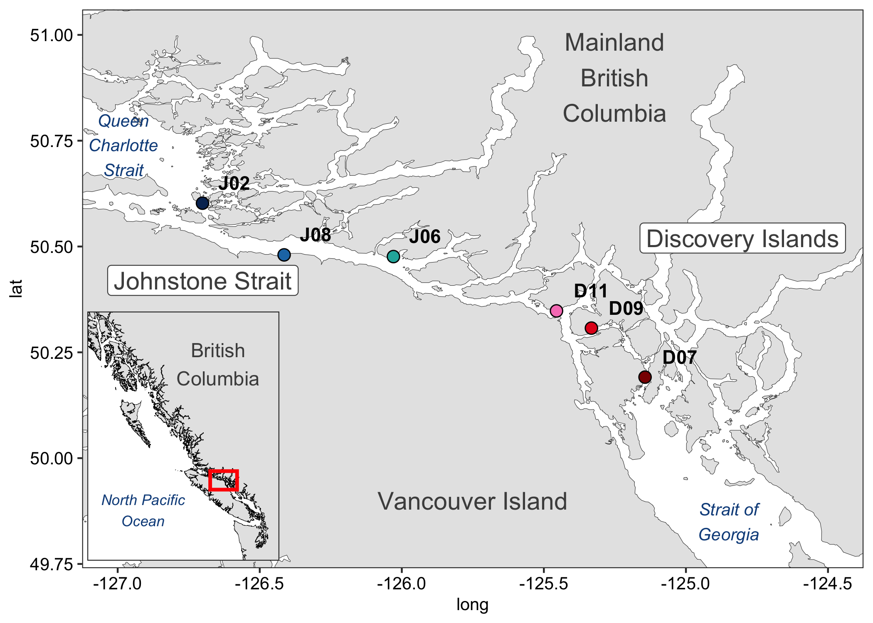

Figure 2.1. Map of salmon survey stations in the Discovery Islands and Johnstone Strait. Inset map (left) shows the British Columbia coast with the study region highlighted by the red box.

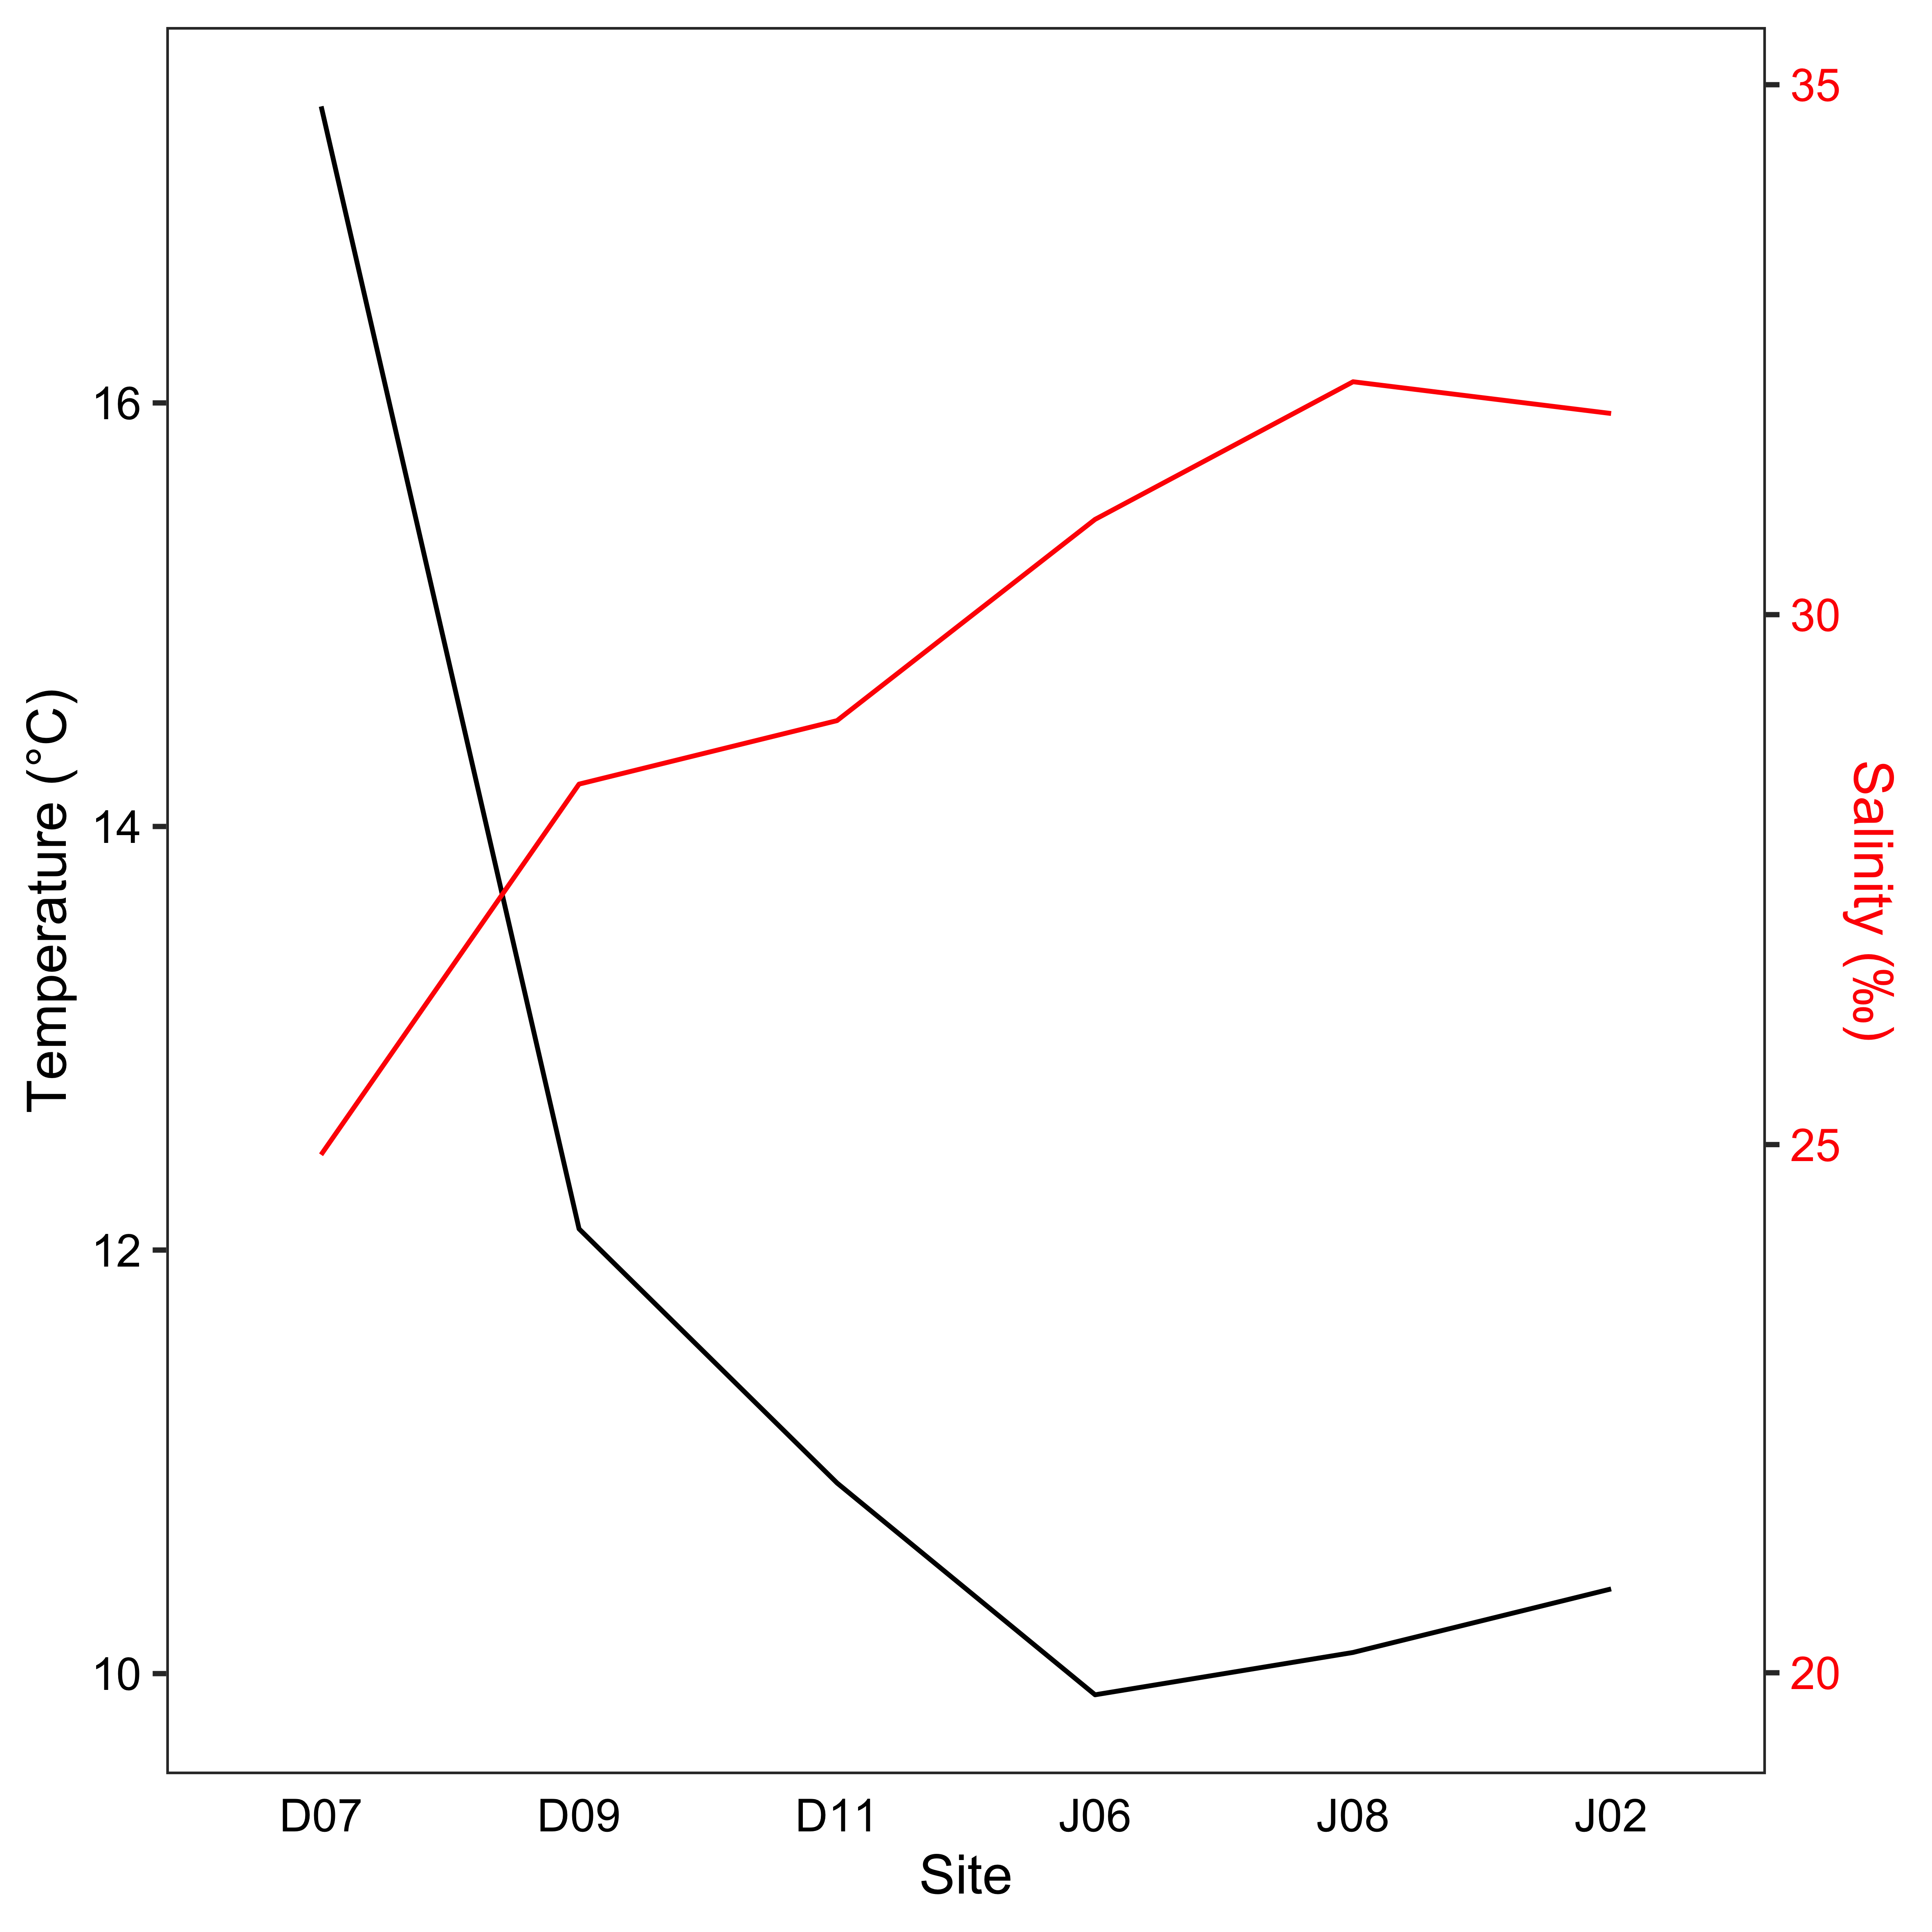

Figure 2.2. Temperature (left y-axis, black) and salinity (right y-axis, red) values paired with the salmon surveys, the sites are listed in the same order on the x-axis as they appear on the map.

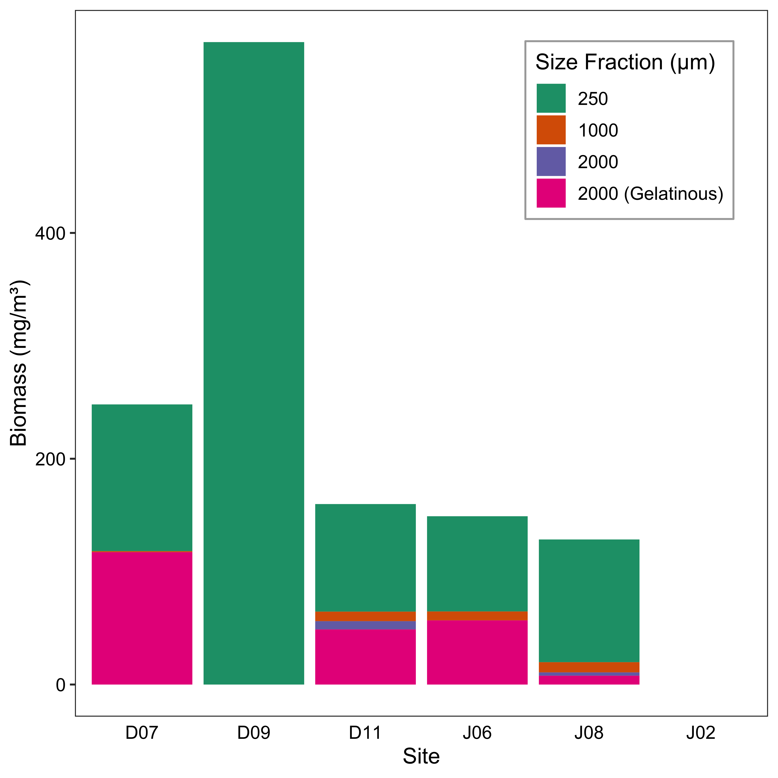

Figure 2.3. Biomass of zooplankton, displaying total biomass and contribution by size fractions. Data are missing for J02 and is shown as blank. Sites are listed in the same order as on the map.



Figure 2.4. Average relative abundance of zooplankton groups, “Other” includes cladocerans, barnacle larvae and euphausiid eggs. Sites are listed in the same order as they appear on the map.



Figure 2.5. Average relative biomass of the main prey groups for juvenile pink (top) and chum salmon (bottom), the sites are listed in the same order on the x-axis as they appear on the map. ‘Other’ prey group includes cyclopoids, barnacles, bivalves, cladocerans, pteropods, and more.

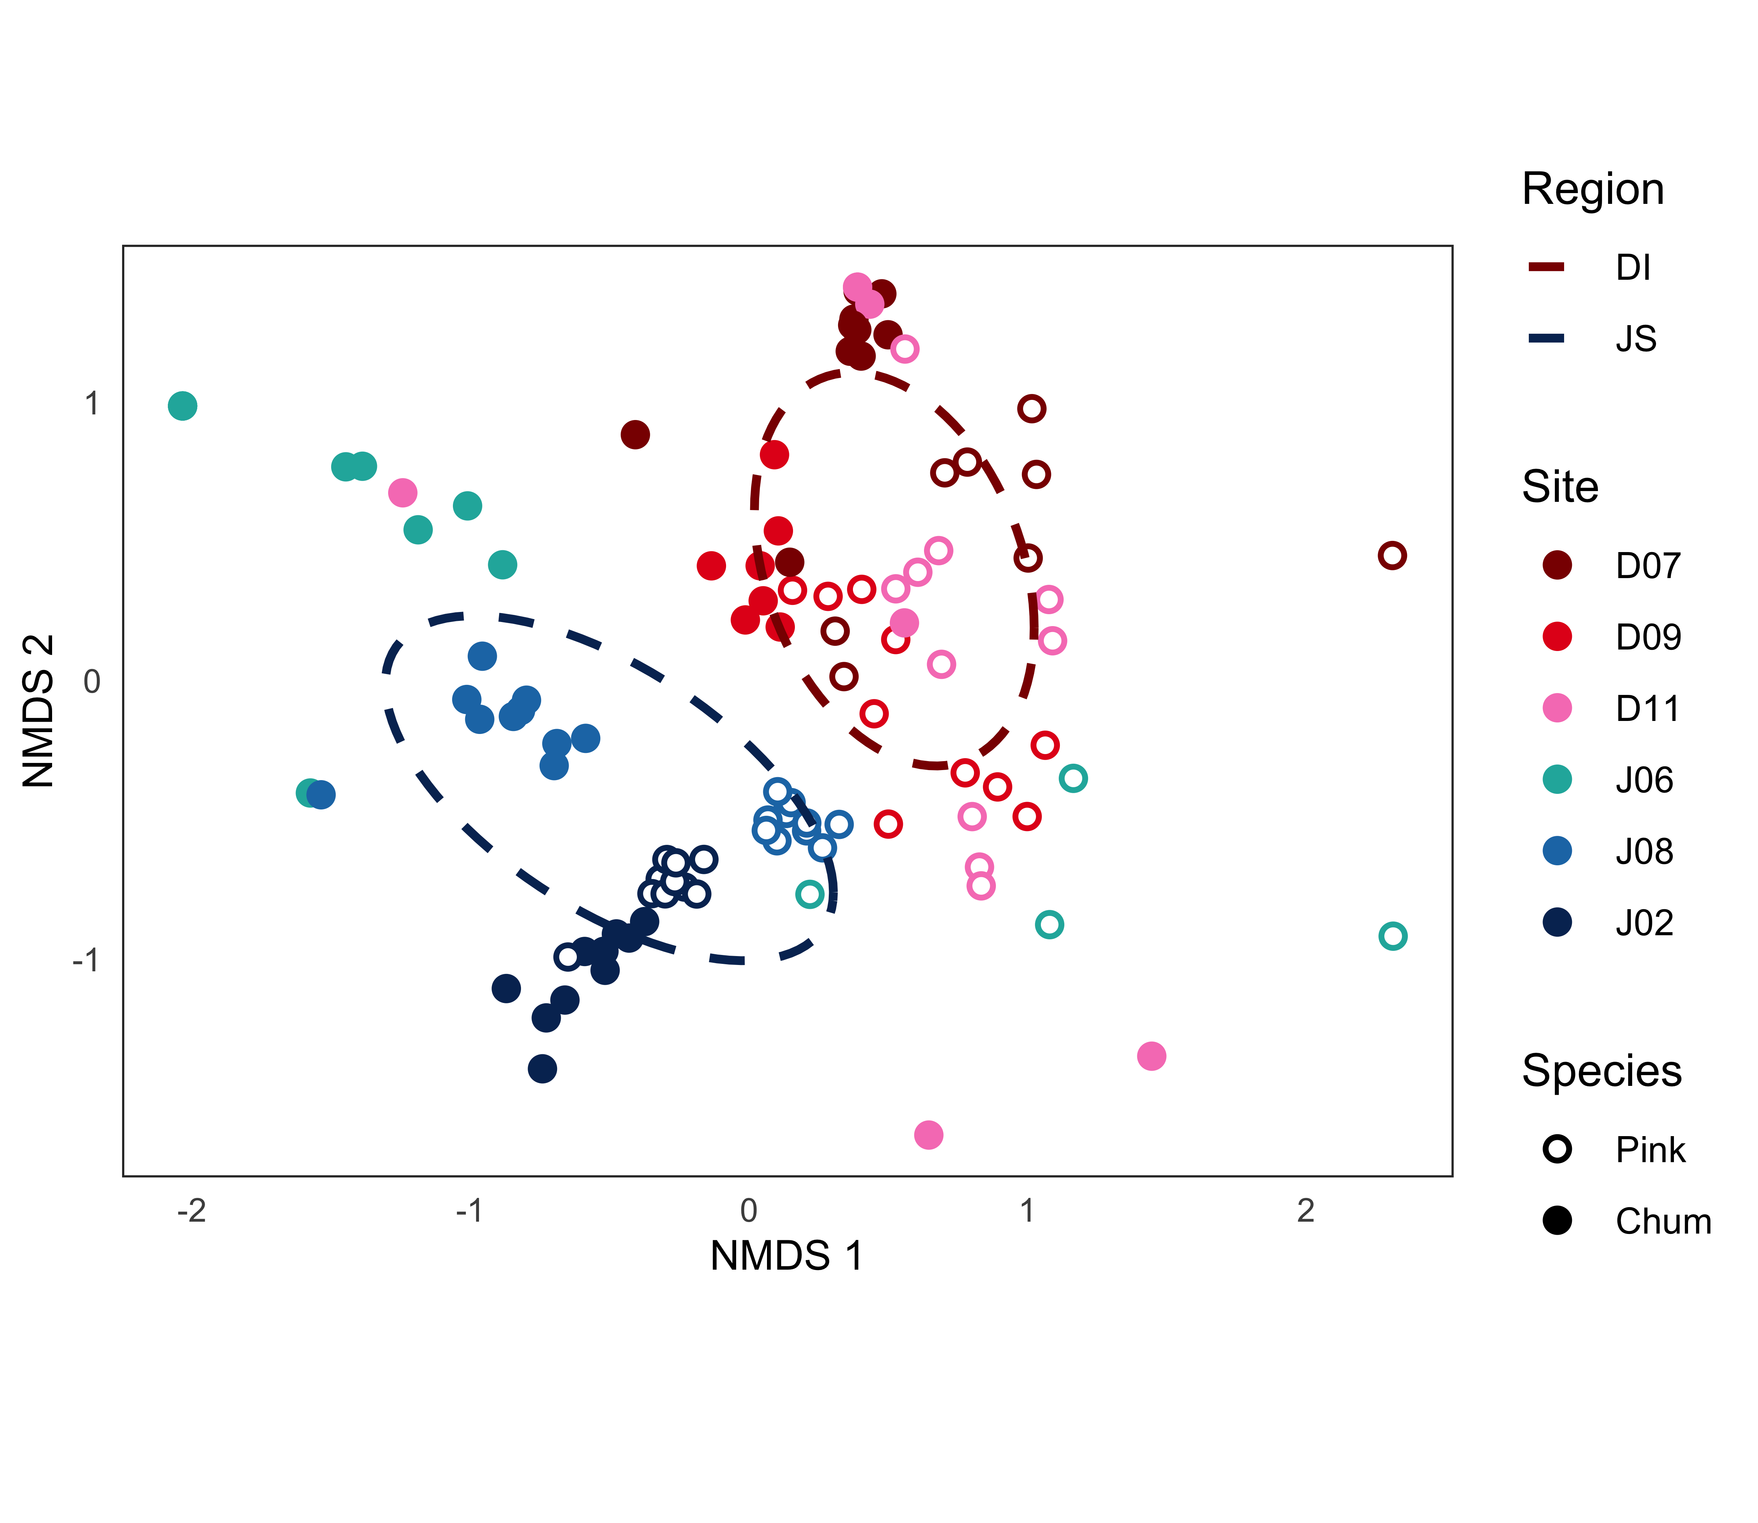

Figure 2.6: Non-metric multidimensional scaling (NMDS) plot of juvenile pink and chum salmon diet composition (see text for data transformations). Each data point is a salmon stomach and distance between points express dissimilarity, axes have no units. Shapes show salmon species, color displays sample site and ellipses indicate standard deviation of each region (see legends). “Stress” is how well distances between points are retained when displayed in two-dimensions, stress values under 0.2 are good representations of data. For this NMDS plot, the stress = 0.17.

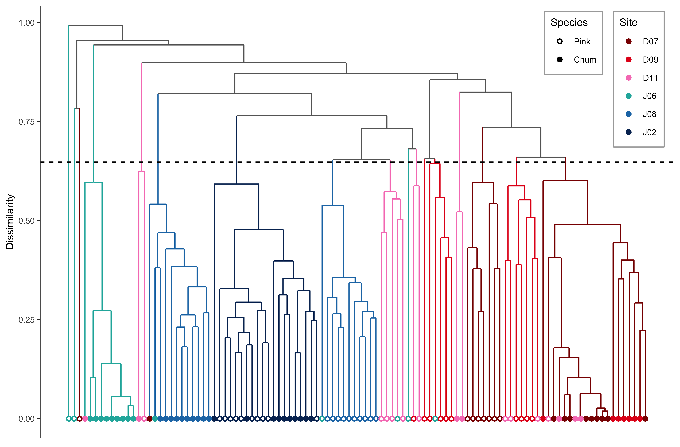

Figure 2.7: Cluster analysis of juvenile pink and chum diet composition, colors represent sites (same color scheme as previous figure).

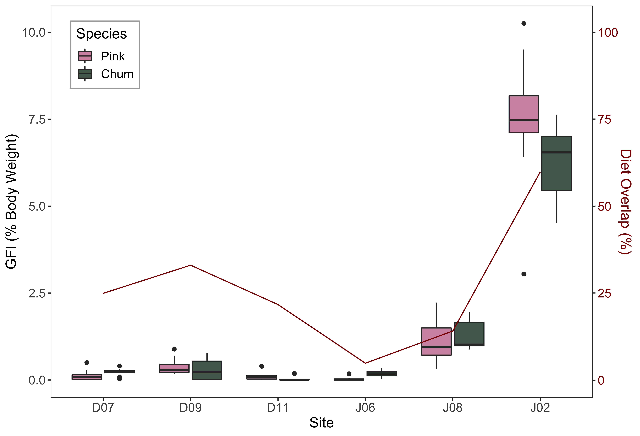

Figure 2.8: Gut fullness index (food weight / fish body weight * 100) values of juvenile pink and chum salmon (left y-axis), the black bar indicates the mean, boxes show the inter-quartile range (IQR), whiskers are data within 1.5*IQR and shown as points are outliers beyond the 1.5*IQR. The dark red line (right y-axis) is the percent similarity or diet overlap index between pink and chum salmon, the sites are listed in the same order on the x-axis as they appear on the map.

## Salmon trophic interactions shift with prey phenology and migration timing

### Introduction

### Methods

### Results

### Discussion

### Conclusion

### Tables

Table 3.1 Sampling



Table 3.2 Zooplankton relative abundance



Table 3.3 Indices



Table 3.4 Diet composition summary (% wet weight) of juvenile salmon by site and year



### Figures

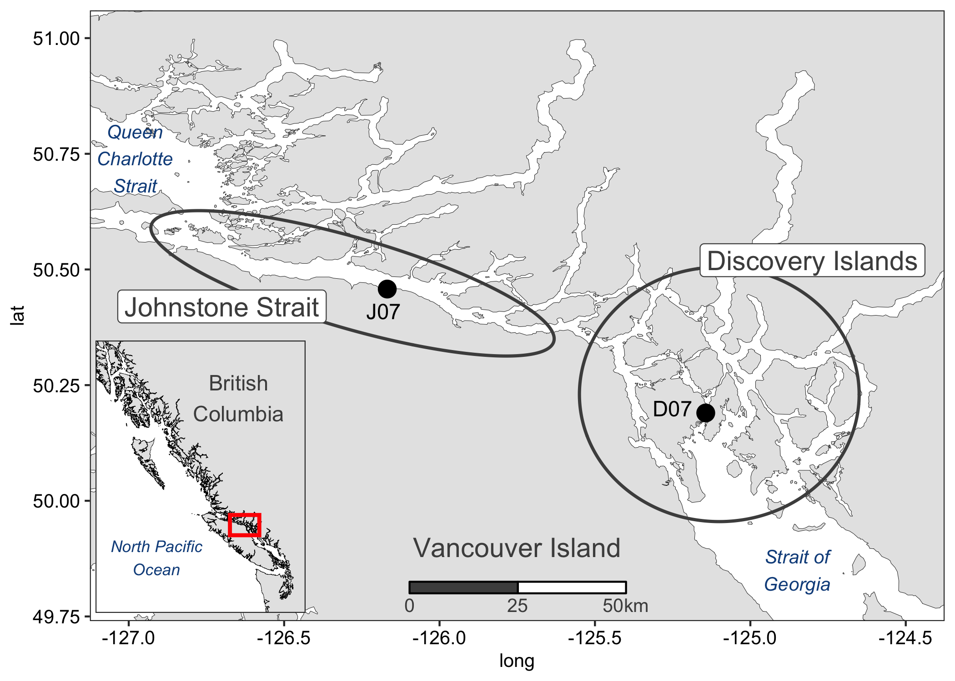

Figure 3.1 Map

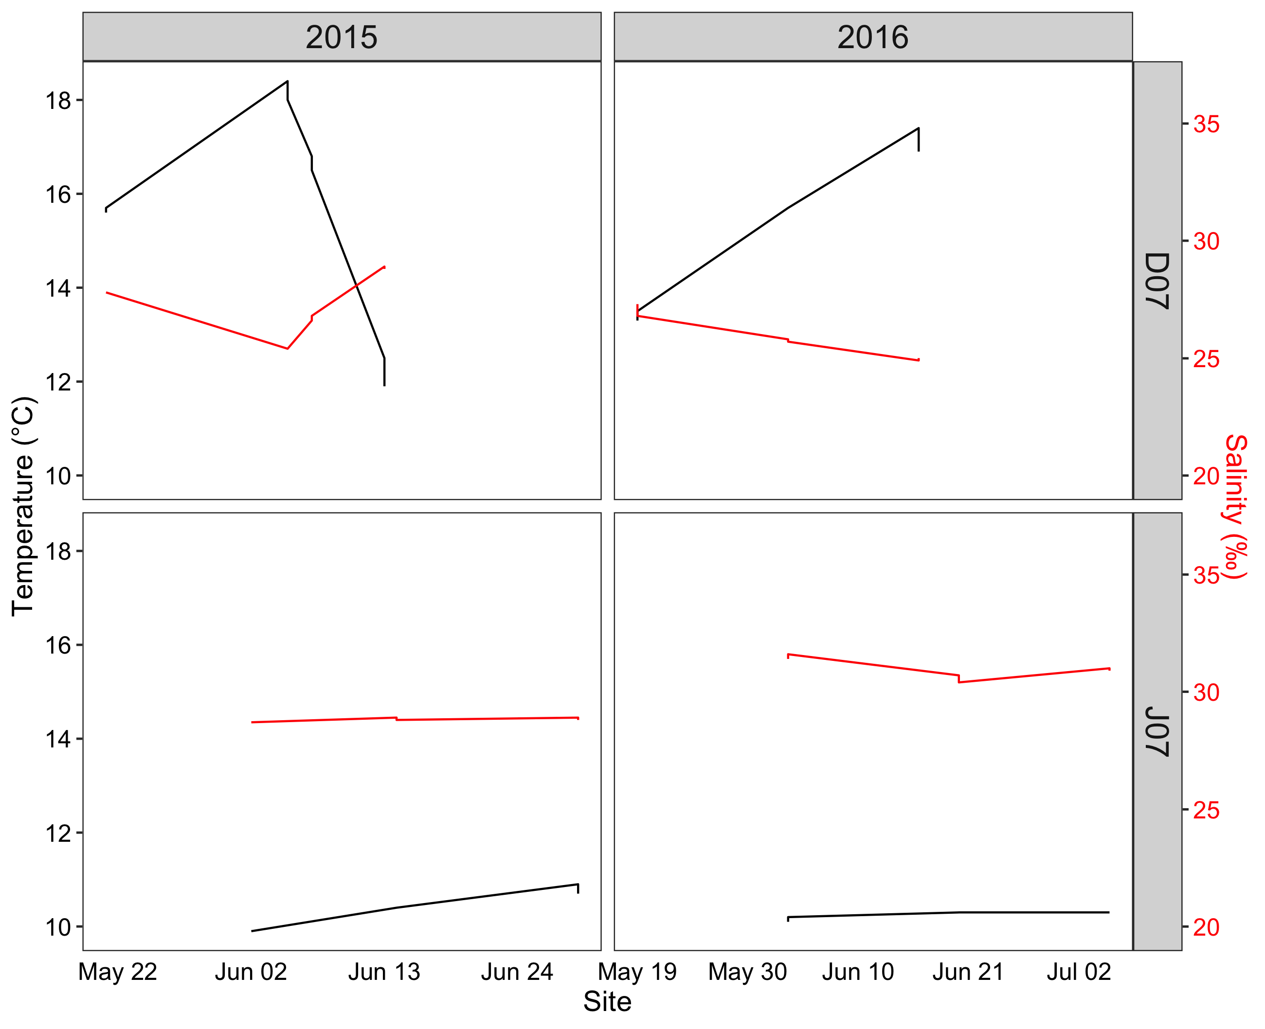

Figure 3.2 Temperature and salinity

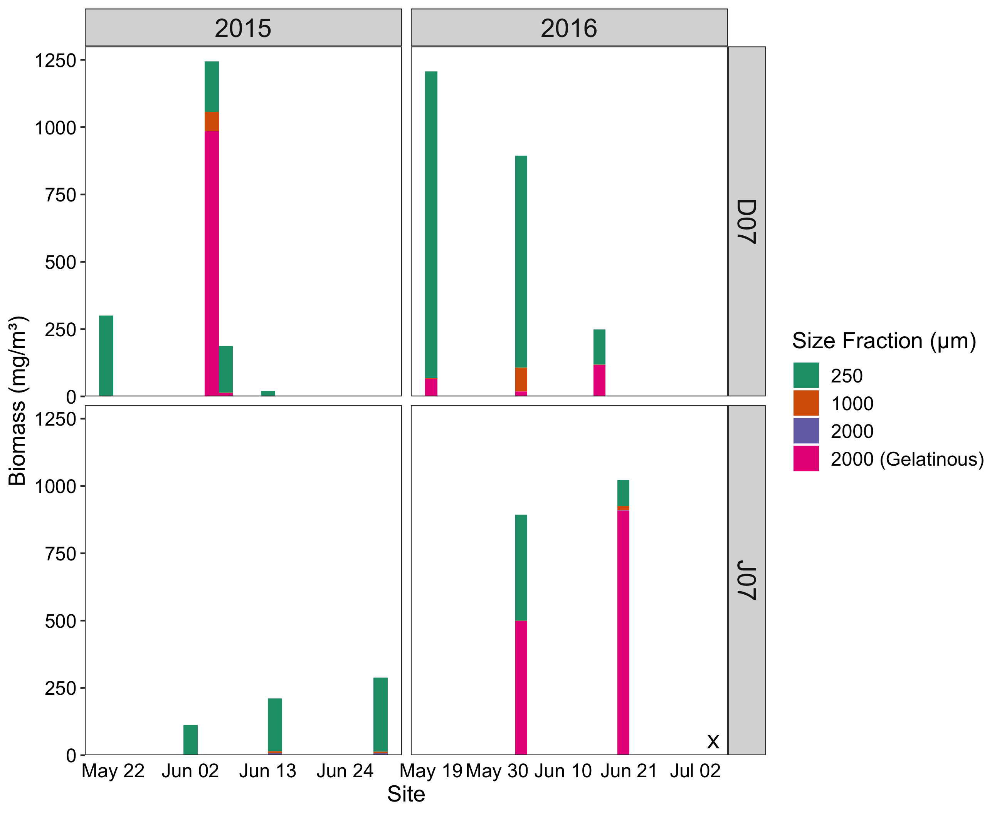

Figure 3.3 Zooplankton biomass by size fraction

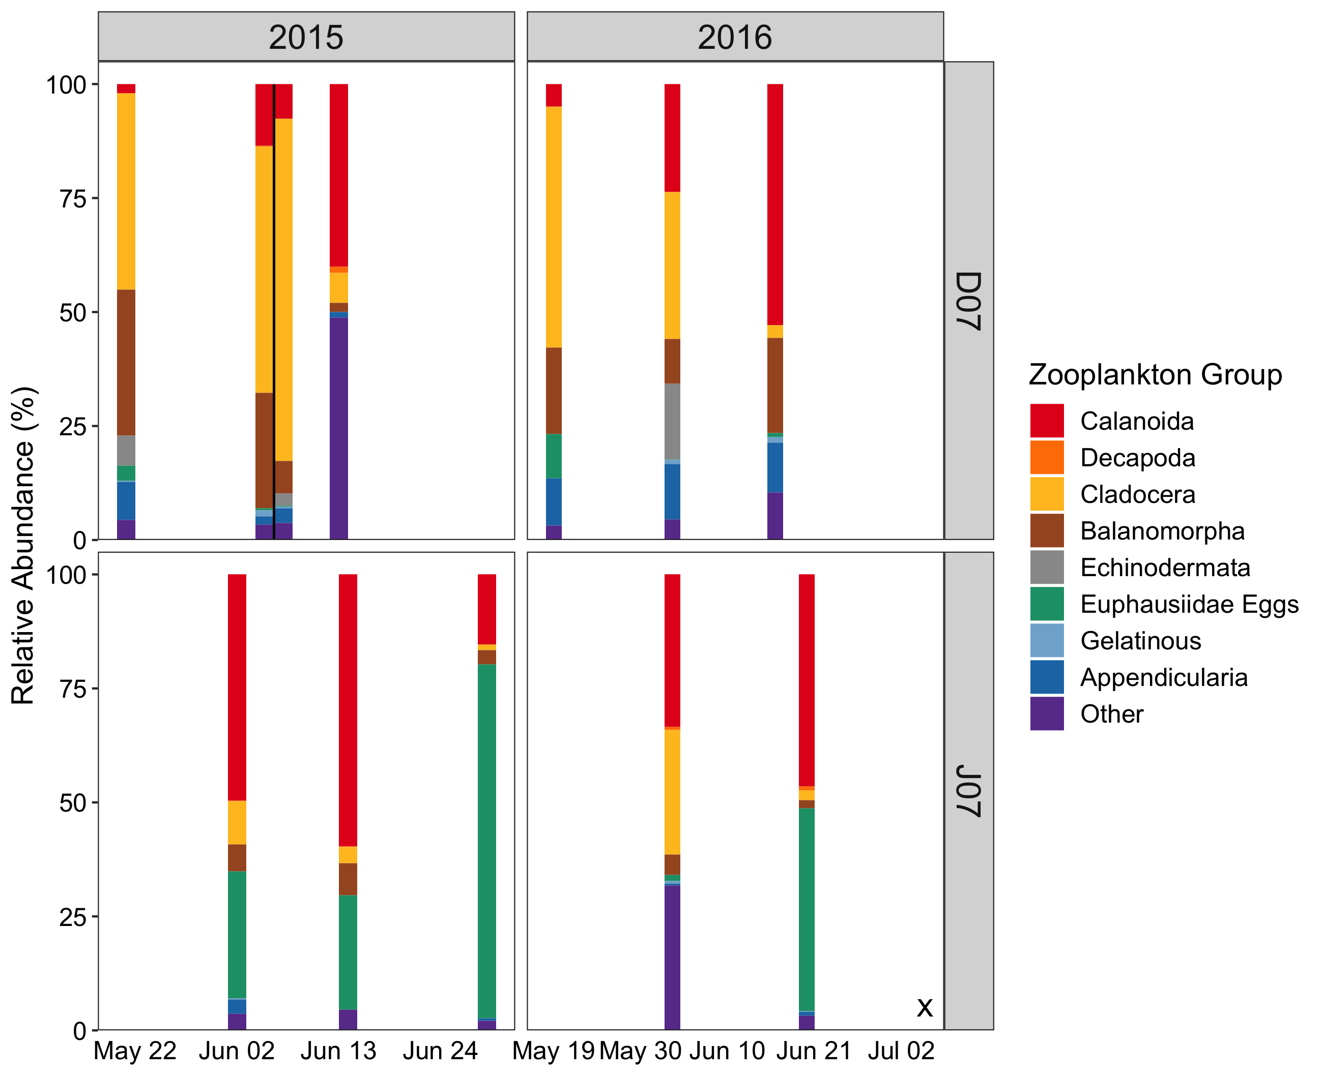

Figure 3.4 Zooplankton relative abundance



Figure 3.5 Diet composition

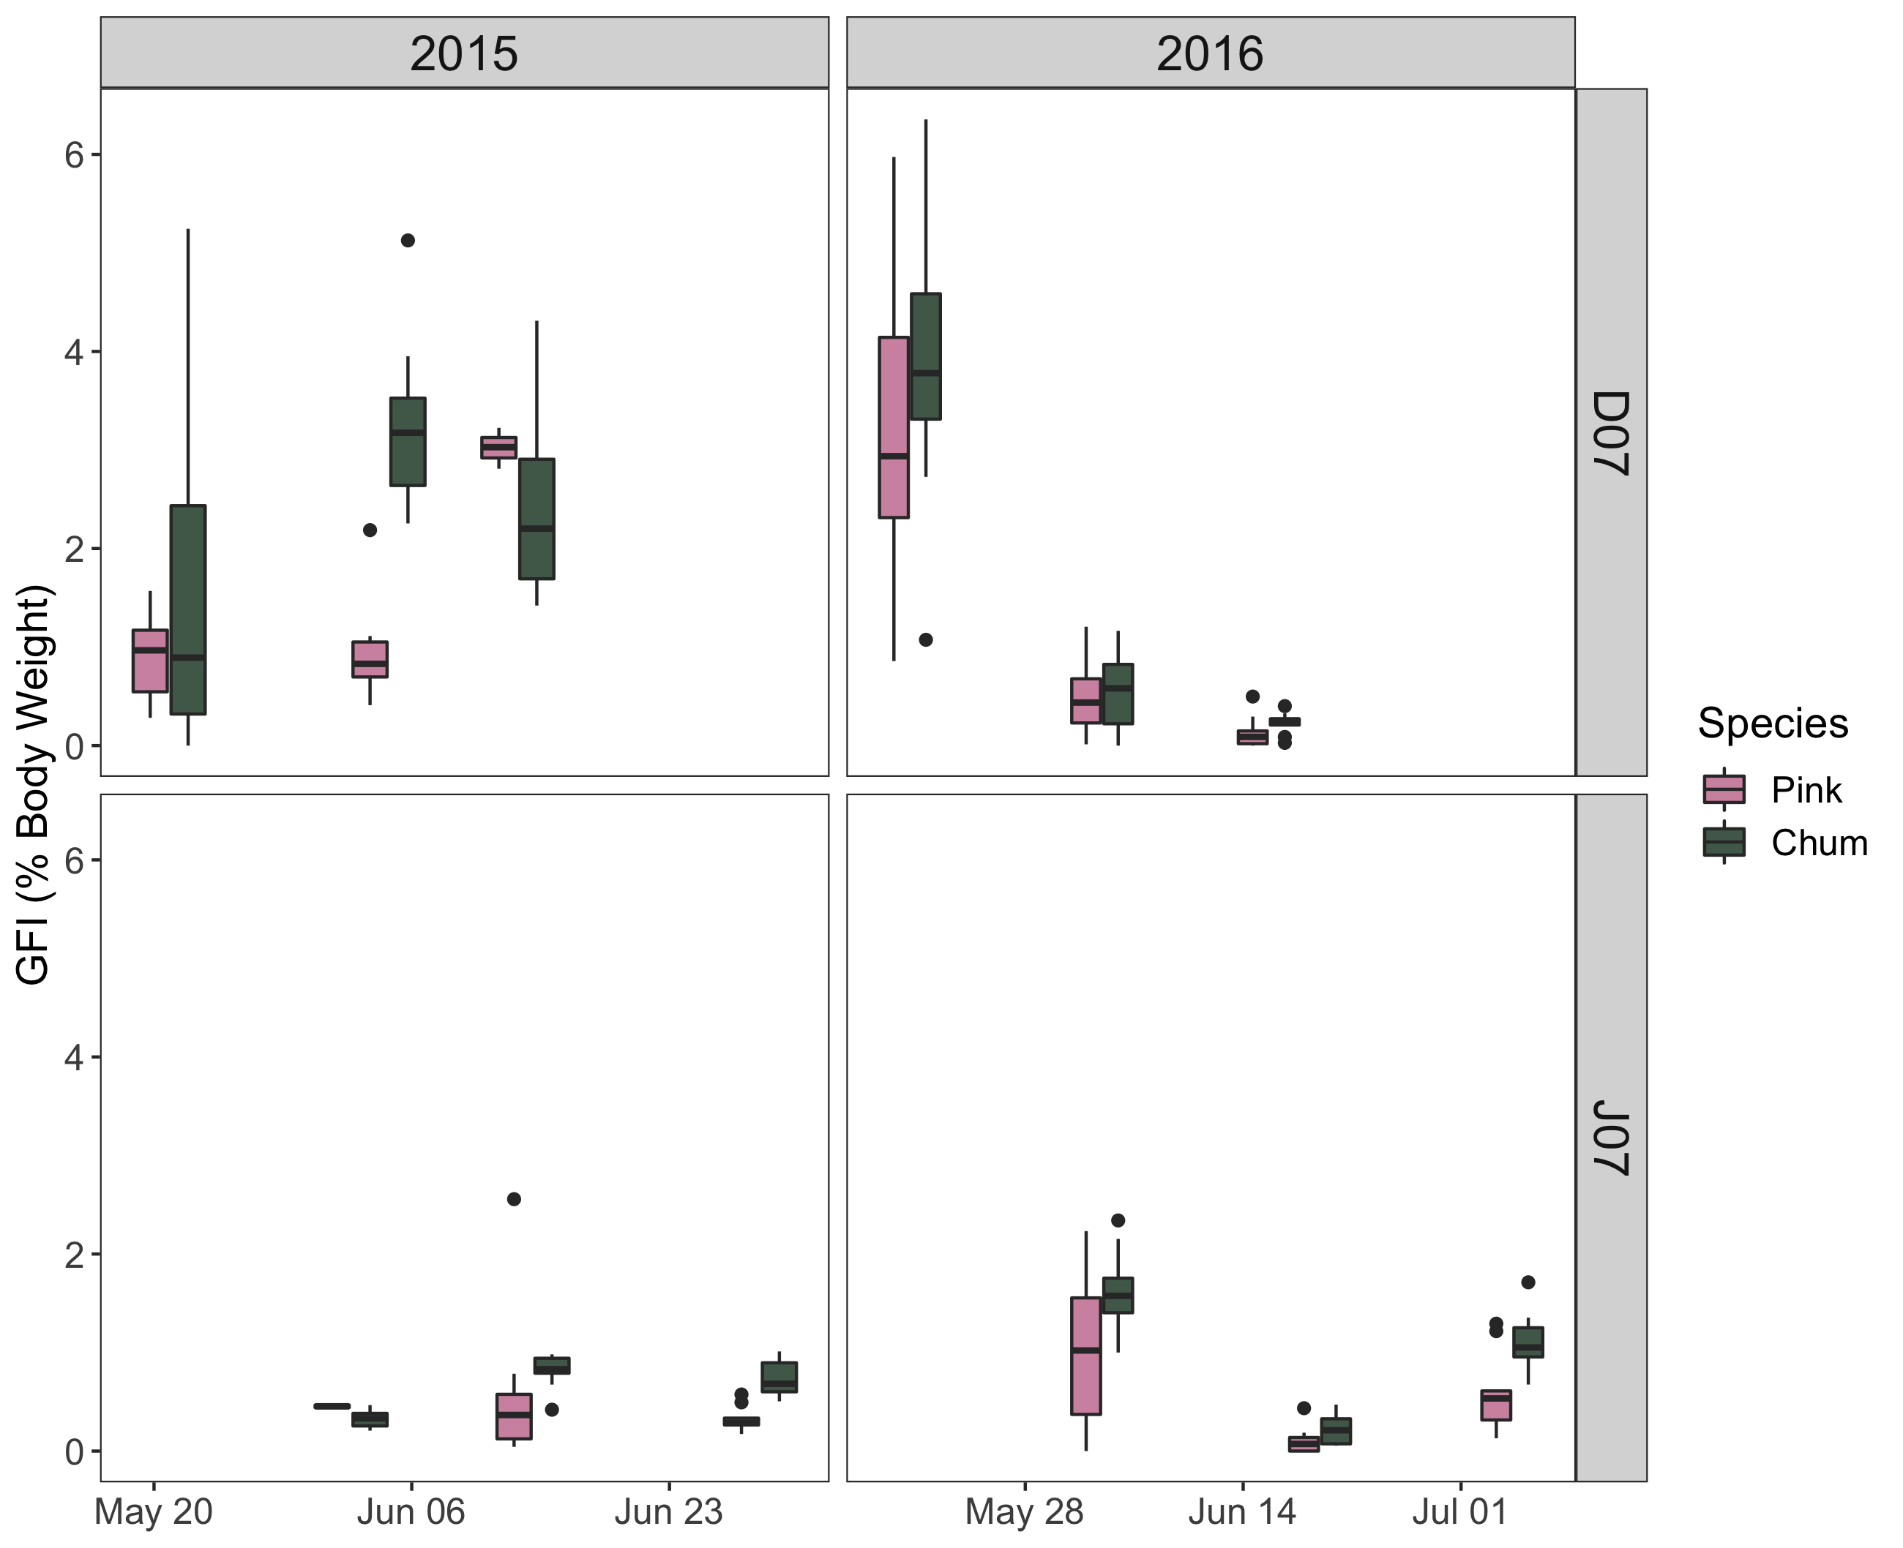

Figure 3.6 GFI

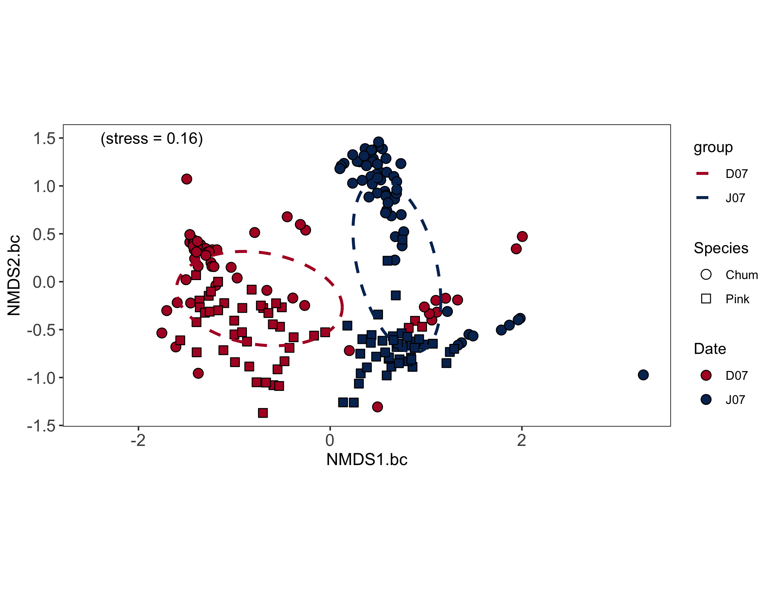

Figure 3.7 NMDS

## Conclusion

TBD …

# References

Batten, S. D., Ruggerone, G. T., & Ortiz, I. (2018). Pink Salmon induce a trophic cascade in plankton populations in the southern Bering Sea and around the Aleutian Islands. *Fisheries Oceanography*, *27*(6), 548–559. https://doi.org/10.1111/fog.12276

Beamish, R. J. (2017). What the past tells us about the future of Pacific salmon research. *Fish and Fisheries*, *18*(6), 1161–1175. https://doi.org/10.1111/faf.12231

Beamish, R. J., & Mahnken, C. (2001). A critical size and period hypothesis to explain natural regulation of salmon abundance and the linkage to climate and climate change. *Progress in Oceanography*, *49*(1–4), 423–437. https://doi.org/10.1016/S0079-6611(01)00034-9

Beamish, R. J., Pearsall, I. a, & Healey, M. C. (2003). A history of the research on the early marine life of Pacific salmon off Canada’s Pacific coast. *NPAFC Bulletin*, *3*(3), 1–40.

Beamish, R. J., Sweeting, R. M., Neville, C. M., & Lange, K. L. (2010). Competitive Interactions Between Pink Salmon and Other Juvenile Pacific Salmon in the Strait of Georgia. *NPAFC Doc. 1284*, *January*.

Brodeur, R. D. (1990). *A synthesis of the food habits and feeding ecoloy of salmonids in marine waters of the North Pacific*. *(INPFC Doc.) FRI*-*UW*-*9016*, 38 p. https://doi.org/FRI-UW-9016

Brodeur, R. D. a, Daly, E. A., Sturdevant, M. V., Miller, T. W., Moss, J. H., Thiess, M. E., Trudel, M., Weitkamp, L. A., Armstrong, J., & Norton, E. C. (2007). Regional comparisons of juvenile salmon feeding in coastal marine waters off the West Coast of North America. *American Fisheries Society Symposium*, *57*(February 2015), 183.

Chase, J. M., & Leibold, M. A. (2003). Introduction: History, context, and purpose. In *Ecological Niches: Linking Classical and Contemporary Approaches* (pp. 1–18).

Chebanova, V. V., Frenkel, S. E., & Zelenikhina, G. S. (2018). Relation of feeding in juvenile chum salmon (Oncorhynchus keta) and pink salmon (o. gorbuscha) to abundance of zooplankton in coastal waters of the prostor bay (iturup island). *Journal of Ichthyology*, *58*(5), 741–750. https://doi.org/10.1134/s0032945218050041

Chipps, S. R., & Garvey, J. E. (2006). Assessment of Food Habits and Feeding Patterns. *American Fischery Society*, *May*, 42.

Choi, J. S., Jung, Y. J., Hong, N. H., Hong, S. H., & Park, J. W. (2018). Toxicological effects of irregularly shaped and spherical microplastics in a marine teleost, the sheepshead minnow (Cyprinodon variegatus). *Marine Pollution Bulletin*, *129*(1), 231–240. https://doi.org/10.1016/j.marpolbul.2018.02.039

Collicutt, B., Juanes, F., & Dudas, S. E. (2019). Microplastics in juvenile Chinook salmon and their nearshore environments on the east coast of Vancouver Island. *Environmental Pollution*, *244*, 135–142. https://doi.org/10.1016/j.envpol.2018.09.137

Daly, E. A., Moss, J. H., Fergusson, E., & Debenham, C. (2019). Feeding ecology of salmon in eastern and central Gulf of Alaska. *Deep-Sea Research Part II: Topical Studies in Oceanography*, *165*(June), 329–339. https://doi.org/10.1016/j.dsr2.2019.06.006

DFO. (2020). *Salmon Southern BC Integrated Fisheries Management Plan*. http://www2.mar.dfo-mpo.gc.ca/fisheries/res/imp/2000grndfish.htm

Garner, K., & Parfitt, B. (2006). First Nations, Salmon Fisheries and the Rising Importance of Conservation. In *Report to the Pacific Fisheries Resource Conservation Council*.

Gill, A. B. (2003). The dynamics of prey choice in fish: The importance of prey size and satiation. *Journal of Fish Biology*, *63*(SUPPL. A), 105–116. https://doi.org/10.1111/j.1095-8649.2003.00214.x

Godin, J. G. J. (1981). Daily patterns of feeding behavior, daily rations, and diets of juvenile pink salmon (oncorhynchus gorbuscha) in two marine bays of british columbia. *Canadian Journal of Fisheries and Aquatic Sciences*, *38*(1), 10–15. https://doi.org/10.1139/f81-002

Groot, C., & Margolis, L. (1991). *Pacific salmon life histories*. University of British Columbia Press.

Hardin, G. (1960). The Competitive Exclusion Principle. *Science*, *131*, 1292–1297.

Healey, M.C. (1991). *Diets and Feeding Rates of Juvenile Pink, Chum, and Sockeye Salmon in Hecate Strait, British Columbia*. *120*, 303–318. https://doi.org/10.1577/1548-8659(1991)120

Healey, Michael C. (1979). Detritus and Juvenile Salmon Production in the Nanaimo Estuary: II. Meiofauna Available as Food to Juvenile Chum Salmon (Oncorhynchus keta). *Journal of the Fisheries Research Board of Canada*, *36*(5), 497–503. https://doi.org/10.1139/f79-073

Healey, Michael C. (2009). Resilient salmon, resilient fisheries for British Columbia, Canada. *Ecology and Society*, *14*(1). https://doi.org/10.5751/ES-02619-140102

Hunt, B. P. V., Johnson, B. T., Godwin, S. C., Krkošek, M., Pakhomov, E. A., & Rogers, L. A. (2018). The Hakai Institute Juvenile Salmon Program : Early Life History Drivers of Marine Survival in Sockeye , Pink and Chum Salmon in British Columbia. *North Pacific Anadromous Fish Commission*, 14.

James, S. E. (2019). *Foraging Ecology of Juvenile Fraser River Sockeye Salmon Across Mixed and Stratified Regions of the Early Marine Migration*. https://doi.org/10.1017/CBO9781107415324.004

James, S. E., Pakhomov, E. A., Mahara, N., & Hunt, B. P. V. (2020). Running the trophic gauntlet: Empirical support for reduced foraging success in juvenile salmon in tidally mixed coastal waters. *Fisheries Oceanography*, *29*(3), 0–2. https://doi.org/10.1111/fog.12471

Jenkins, E. (2011). *Trophic niche and foodweb dynamics within and among juvenile salmon species in years of contrasting ocean conditions*.

Johnson, B., Gan, J., Godwin, S., Krkosek, M., & Hunt, B. (2019). Juvenile Salmon Migration Observations in the Discovery Islands and Johnstone Strait in 2018 Compared to 2015–2017. *Technical Report*, *15*, 31–39. https://doi.org/10.23849/npafctr15/31.39.

Johnson, S. P., & Schindler, D. E. (2009). Trophic ecology of Pacific salmon (Oncorhynchus spp.) in the ocean: A synthesis of stable isotope research. *Ecological Research*, *24*(4), 855–863. https://doi.org/10.1007/s11284-008-0559-0

Khangaonkar, T., Long, W., & Xu, W. (2017). Assessment of circulation and inter-basin transport in the Salish Sea including Johnstone Strait and Discovery Islands pathways. *Ocean Modelling*, *109*, 11–32. https://doi.org/10.1016/j.ocemod.2016.11.004

Krebs, C. J. (2013). Niche measures and resource preferences. In *Ecological Methodology* (pp. 597–651).

Levings, C. D. (2016). *Ecology of salmonids in estuaries around the world: adaptations, habitats, and conservation*. University of British Columbia Press.

Mackas, D. L., Thomson, R. E., & Galbraith, M. (2001). Changes in the zooplankton community of the British Columbia continental margin, 1985-1999, and their covariation with oceanographic conditions. *Canadian Journal of Fisheries and Aquatic Sciences*, *58*(4), 685–702. https://search.proquest.com/docview/219273927?pq-origsite=summon&accountid=14656

Mahara, N. (2018). *Zooplankton Community Composition Across a Range of Productivity Regimes in Coastal British Columbia*.

Malick, M. J., & Cox, S. P. (2016). Regional-scale declines in productivity of pink and chum salmon stocks in western North America. *PLoS ONE*, *11*(1), 1–23. https://doi.org/10.1371/journal.pone.0146009

Marushka, L., Kenny, T. A., Batal, M., Cheung, W. W. L., Fediuk, K., Golden, C. D., Salomon, A. K., Sadik, T., Weatherdon, L. V., & Chan, H. M. (2019). Potential impacts of climate-related decline of seafood harvest on nutritional status of coastal First Nations in British Columbia, Canada. *PLoS ONE*, *14*(2), 1–24. https://doi.org/10.1371/journal.pone.0211473

Mckinnell, S., Curchitser, E., Groot, K., Kaeriyama, M., & Trudel, M. (2014). Oceanic and atmospheric extremes motivate a new hypothesis for variable marine survival of Fraser River sockeye salmon. *Fisheries Oceanography*, *23*(4), 322–341. https://doi.org/10.1111/fog.12063

Mcqueen, D., & Ware, D. (2006). *Handbook of Physical, Chemical, Phytoplankton, and Zooplankton Data from Hecate Strait, Dixon Entrance, Goose Island Bank and Queen Charlotte Sound*. 133. http://skeenasalmonprogram.ca/libraryfiles/lib_236.pdf

Osgood, G. J., Kennedy, L. A., Holden, J. J., Hertz, E., McKinnell, S., & Juanes, F. (2016). Historical diets of forage fish and juvenile pacific salmon in the strait of Georgia, 1966-1968. *Marine and Coastal Fisheries*, *8*(1), 580–594. https://doi.org/10.1080/19425120.2016.1223231

Pearson, W. H., Deriso, R. B., Elston, R. A., Hook, S. E., Parker, K. R., & Anderson, J. W. (2012). Hypotheses concerning the decline and poor recovery of Pacific herring in Prince William Sound, Alaska. *Reviews in Fish Biology and Fisheries*, *22*(1), 95–135. https://doi.org/10.1007/s11160-011-9225-7

Pocheville, A. (2015). The ecological niche: History and recent controversies. In *Handbook of Evolutionary Thinking in the Sciences* (Issue January). https://doi.org/10.1007/978-94-017-9014-7_26

Quinn, T. P. (2018). *The behaviour and ecology of Pacific salmon and trout* (Second). University of Washington Press.

Ruggerone, G. T., & Irvine, J. R. (2018). Numbers and Biomass of Natural- and Hatchery-Origin Pink Salmon, Chum Salmon, and Sockeye Salmon in the North Pacific Ocean, 1925–2015. *Marine and Coastal Fisheries*, *10*(2), 152–168. https://doi.org/10.1002/mcf2.10023

Ruggerone, G. T., & Nielsen, J. L. (2004). Evidence for competitive dominance of Pink salmon (Oncorhynchus gorbuscha) over other Salmonids in the North Pacific Ocean. *Reviews in Fish Biology and Fisheries*, *14*(3), 371–390. https://doi.org/10.1007/s11160-004-6927-0

Ruggerone, G. T., Springer, A. M., Shaul, L. D., & van Vliet, G. B. (2019). Unprecedented biennial pattern of birth and mortality in an endangered apex predator, the southern resident killer whale, in the eastern North Pacific Ocean. *Marine Ecology Progress Series*, *608*(1), 291–296. https://doi.org/10.3354/meps12835

Springer, A. M., Van Vliet, G. B., Bool, N., Crowley, M., Fullagar, P., Lea, M. A., Monash, R., Price, C., Vertigan, C., & Woehler, E. J. (2018). Transhemispheric ecosystem disservices of pink salmon in a Pacific Ocean macrosystem. *Proceedings of the National Academy of Sciences of the United States of America*, *115*(22), E5038–E5045. https://doi.org/10.1073/pnas.1720577115

Tadokoro, K., Ishida, Y., Davis, N. D., Ueyanagi, S., & Sugimoto, T. (1996). Change in chum salmon (Oncorhynchus keta) stomach contents associated with fluctuation of pink salmon (O. gorbuscha) abundance in the central subarctic Pacific and Bering Sea. *Fisheries Oceanography*, *5*(2), 89–99. https://doi.org/10.1111/j.1365-2419.1996.tb00108.x

Weingartner, T., Eisner, L., Eckert, G. L., & Danielson, S. (2009). Southeast Alaska: Oceanographic habitats and linkages. *Journal of Biogeography*, *36*(3), 387–400. https://doi.org/10.1111/j.1365-2699.2008.01994.x

Welch, D. W. (1997). Anatomical specialization in the gut of Pacific salmon (Oncorhynchus): Evidence for oceanic limits to salmon production? *Canadian Journal of Zoology*, *75*(6), 936–942. https://doi.org/10.1139/z97-112

Wyllie de Echeverria, V. R., & Thornton, T. F. (2019). Using traditional ecological knowledge to understand and adapt to climate and biodiversity change on the Pacific coast of North America. *Ambio*, *48*(12), 1447–1469. https://doi.org/10.1007/s13280-019-01218-6

# Appendix

Table A.1: Diet composition summary of juvenile salmon for each sampling date 2015-2016

